Calgary Housing Company 2021 Resident Satisfaction Survey Summary
Calgary Housing Company strives to understand resident experiences to better deliver affordable housing to Calgarians in need.
As a wholly owned subsidiary of the City of Calgary, Calgary Housing Company (CHC) works with other levels of government, non-profits, and private sector partners to provide safe and affordable housing solutions for low- and moderate-income Calgarians. CHC manages over 7,000 affordable homes, serving nearly 25,000 Calgarians, including almost 10,000 children. CHC regularly conducts a Resident Satisfaction Survey to provide residents with an opportunity to give feedback on CHC’s service delivery and share information about their well-being. The results are used by CHC to continually improve service delivery and better support resident and community well-being. The most recent survey was conducted via telephone and online from May 31 to June 17, 2021. A total of 600 residents completed the survey. This summary provides an overview of the key results and CHC’s response. You can read the full results here.
This survey builds off previous surveys conducted in 2017 and 2019. The results will be used to monitor and direct decisions that matter to the people who call CHC-managed housing home.
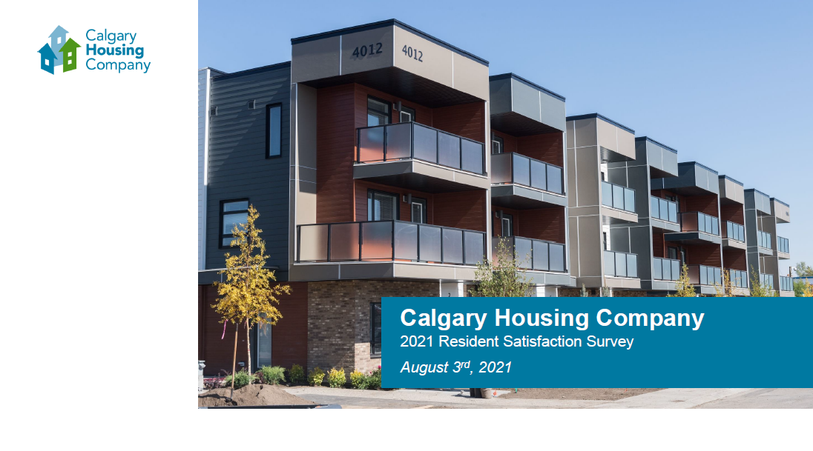

About the Respondents
A total of 600 residents completed the survey; responses were proportionately distributed across all areas of Calgary. The results also include all three of CHC’s program types – Social Housing (Deep Subsidy), Affordable Housing (Moderate Subsidy), and Low End of Market Housing (Low subsidy). The respondents were:
- 57% female and 40% male
- 7% members of LGTBQ+ community
- 28% aged 18-34; 48% aged 35-54, and 22% aged 55+
- 36% employed full time; 18% looking for work and 12% unable to work
- 48% were born outside of Canada
- 42% identified as White, 25% identify as Black, 7% identify as Indigenous and 7% identify as Arab/Middle Eastern
- 33% were single-parent households and 30% were one-person households
- 23% identified as having a disability in the household (Mobility issues were indicated by 46% of people with a disability).

Calgary Housing Company’s Overall Satisfaction:
- The overall satisfaction with services provided by CHC remains high at 74%. Overall satisfaction with CHC has remained relatively stable and was 73% in 2019 and 77% in 2017. Key drivers of overall resident satisfaction, in order of importance, were the level of crime that occurs in their building, most recent contact with CHC, being listened to and treated with respect, the condition of their home, how promptly CHC addresses safety concerns and the level of safety and security in their building/home.
- 84% of respondents were satisfied with being listened to and treated with respect, and 78% were comfortable raising concerns or speaking their mind with CHC. The majority of residents agreed that CHC supports diversity and inclusion (78%) and that CHC cares about their well-being (66%) and 73% of residents were proud of their home.
Safety and Security:
The 2021 survey included an expanded section on safety and security in response to feedback raised through past surveys. Overall, 68% of residents were satisfied with their level of safety and security in their building and home. This is a significant increase of 8% since 2019. 75% of residents were satisfied with the security of their home, and 73% were satisfied with how safe they felt in their building/property. While satisfaction with level of safety walking alone around their property during the day was high (88%), satisfaction drops significantly at night (59%). In Calgary as a whole, 79% of residents feel safe walking alone at night. Residents in high-rise buildings were less satisfied on all these measures than those living in low-rise buildings and townhomes. Demographic analyses revealed higher satisfaction with feeling of safety amongst White, male residents without a disability.
Overall, residents were very satisfied with the building evacuation plans, such as emergency exits and egress windows, ice and snow removal (71%) and how promptly CHC addresses safety concerns (71%). 20% of residents were dissatisfied with the level of crime that occurs around their property.
To improve feelings of safety and security in their building/property, residents suggested more security/regular patrolling or an on-site security guard (20%), security cameras (20%), better locks and doors (12%) and better lighting (11%). Residents aged 55+ and from the south were more likely to suggest an onsite security guard. Residents in high-rise buildings were more likely to suggest on-site security, whereas residents living in townhomes were more likely to suggest better lighting.
CHC will continue to strengthen safety and security through the prioritization of safety-related repairs, and security improvements, and by maintaining an open and responsive relationship with our residents so that safety-related concerns can be voiced and addressed.
Application, Leasing Signing and Move-In:
Residents were very satisfied with the application process (82%).
Satisfaction with the lease signing process rose by 5% to 87% in 2021. This was the only statistically significant change from 2019 to 2021 reported in the survey. Residents agreed that staff who signed their lease were professional and provided the information they needed (92%). Suggestions to improve the lease signing process included simplifying and shortening the process.
Residents were very satisfied with the move-in process (83%) and agreed that the staff who did the move-in inspection were professional and thorough (89%). 85% of residents did not have any major problems when moving in (e.g., parking, elevator access). Although residents in high-rise buildings were more likely to have problems moving-in compared to residents in townhouses.
CHC continues to improve the application process. CHC launched an Applicant portal in March 2021. The portal allows people to submit their applications online as well as check their status and submit any updates. The CHC Tenant Handbook provides important information for residents, such as how to connect with CHC, guidance on the programs we provide, and advice on maintenance and management of the home.
Condition of Property, Building and Home and Maintenance:
Although satisfaction rates with building and home have increased compared to 2019, they remain an area for improvement. 64% of residents said they were satisfied with the condition of their property, 59% were satisfied with the condition of their building and 69% were satisfied with condition of the home.
32% of residents identified overall maintenance issues as the primary issue they face in relation to their housing. Other top concerns residents had with their properties are other residents (neighbors), poor communication, lack of cleanliness and security issues.
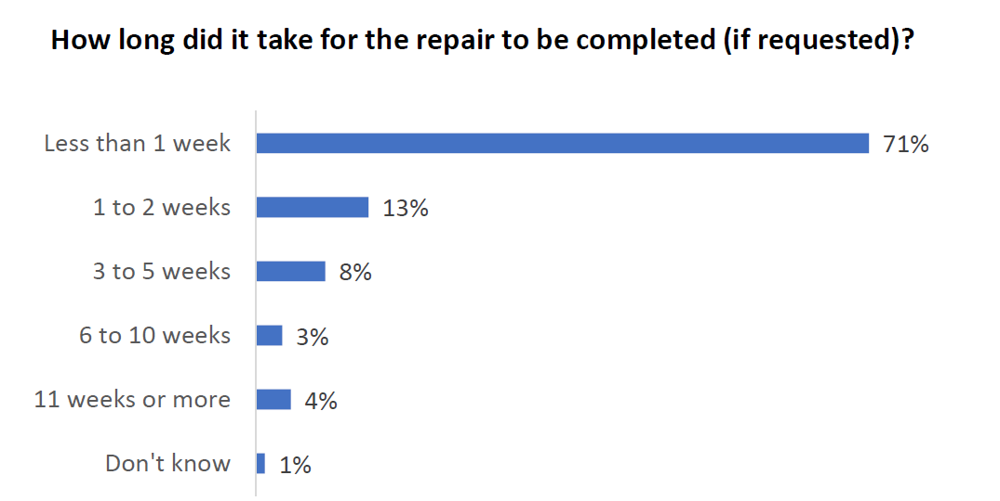
Residents who responded to the survey were generally satisfied with repair quality at 82%, and timeliness of repairs at 79%. Over a third of the survey respondents had a repair completed within the last 3 months of the survey date and the top types of repairs were plumbing at 40%, general maintenance at 12% and appliance at 10%.
Nearly one third of recent repairs were initiated by CHC, which reflects our efforts to become more proactive. Additionally, three quarters of recent repairs took place within one week of request. Resident satisfaction with the courtesy of building maintenance workers during these repairs was the top-rated question in the survey at 93%.
CHC has strategies and plans to proactively manage our assets and ensure properties are in good condition. This includes advocacy to ensure adequate funding for this work.

Contact and Communication:
One quarter of the residents surveyed had contacted CHC within the week and another quarter of residents surveyed had contacted CHC within the last month. The top reasons for last contact were maintenance at 41%, lease renewal at 18%, and 11% was to lodge a complaint. Two thirds of residents indicated they used a phone as their most recent method of contact.
Residents also indicated a strong preference for phones as the primary method for CHC to contact them at nearly three quarters. Satisfaction with response time from phone calls to a direct line is an area for improvement at 68%.
CHC has launched a resident portal that allows residents to immediately access information about their accounts and submit maintenance requests without having to wait for a response to a phone call. The portal provides a valuable option for residents and frees up staff time to support residents through the Customer Service Line and in-person. CHC continues to offer the Customer Service Line and is getting ready to reopen our front counters after closure due to COVID-19.
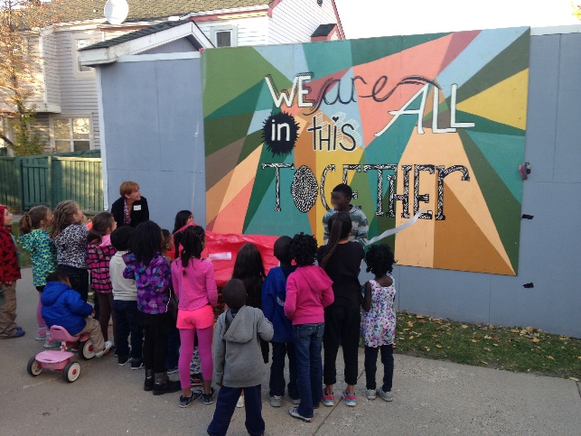
Resident and Community Well-being and Future Plans:
The following survey results explore resident and community well-being and future plans. Delivering quality services to contribute to individual and community well-being is one of CHC’s strategic priorities.
- 62% of residents reported a good quality of life (compared to 79% of Calgarians as of July 2021)
- Factors that contributed to good quality of life are happy/healthy/satisfied/life is good, good place to live, have a good job/income and housing is affordable
- Factors that contributed to poor quality of life are health issues/mental health issues, financial troubles/high cost of living, home is uncomfortable and unemployment/lack of jobs
- In terms of community-wellbeing, 69% of residents were satisfied with their level of engagement with others in their building, and 65% were satisfied with their community as a whole. 58% agreed that people pull together to help neighbors in need and 58% said they know their neighbors well enough to be able to ask for support if they need it.
- Only 15% of respondents had used the support services of CHC’s tenant liaisons in the last year. While satisfaction with these services was high (83% were satisfied), only about half of respondents were aware of these services (54%).
- 30% of respondents plan to move out within 2 years, 20% plan to move out in 3-5 years and 16% of residents plan to move out in 5-10 years. 18% of residents have no plans to move out and 15% were not sure about their plans.
CHC continues to support resident and community well-being through partnerships with agencies and through the services of our Tenant Liaisons. CHC will be looking at developing an onboarding program to help connect new residents with community events and resources, starting in 2023.
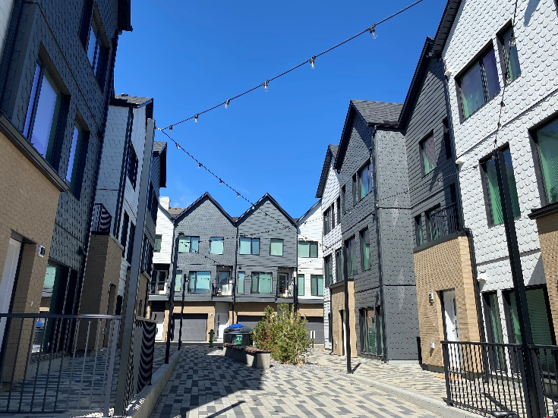
Diversity and Inclusion
7
November, 2019
2019 Tenant Satisfaction Survey
Our respondent profile indicates that in comparison to the general Calgary population, a greater proportion of CHC residents were born outside of Canada (48% vs. 28%) and indicated the presence of a disability in the household (23% vs. 17%). More CHC residents identify as Indigenous and racialized.
In comparison to the general Calgary population, a greater proportion of CHC residents report living in a one-person household (30% vs. 25%) and a single-parent household (33% vs. 7.4%).
Overall, 78% of residents agreed that CHC supports diversity and inclusion, while two-thirds (66%) agreed that CHC cares about their well-being.
Furthermore, 84% of residents felt satisfied with being listened to and treated with respect and 78% were satisfied with being comfortable raising concerns or speaking their mind with CHC. This was consistent across all demographics represented in CHC.
Some demographic differences did emerge:
- Results indicate racialized residents and those with a disability were significantly less satisfied with all areas of safety and security than other residents. Further, men were more likely to report greater levels of agreement with safety walking alone around their property after dark compared to women.
- Single parents with children were significantly more aware of the support services available through tenant liaisons. Usage of these services was greatest among single parents and women.
- Residents aged 55+ were significantly more likely to indicate they do not have plans to move out compared to those aged 18-34.
- Quality of life was significantly lower amongst residents with a disability.
- Lack of connection to one’s neighbours was highest among one-person household and single parents.
CHC will continue supporting equity, diversity, and inclusion through ongoing employee education and training and the development of an anti-racism strategy. CHC will also continue to provide support for residents, including specialized support through partnerships with other agencies. We will revise policies such as the eviction prevention policy to strengthen housing stability and develop an acceptable housing policy to guide decisions around accessible housing.
The Impact of COVID-19
Overall, residents indicated that they were highly satisfied with CHC’s response to the COVID-19 pandemic. Residents were aware of the efforts by CHC to limit the spread of COVID-19 (92%) and believed CHC’s response was quick (89%) and helpful (88%).
Residents indicated a worsening in their mental health (30%), physical health (25%) and personal financial situation (29%) compared to before the pandemic. Few residents witnessed positive change in these areas through the course of the pandemic. Among those who did, 18-34-year-old residents were significantly more likely to note that their mental health (18%), physical health (22%), and personal financial situation (23%) improved throughout the course of the pandemic.
The 2021 Citizen Perspectives Survey – COVID-19 Snapshot #11 from July 2021 reported similar worsening of physical health (33%) and personal financial situation (34%), and greater levels of worsening of mental health (48%) for the general Calgary population compared to CHC residents. These results suggest that affordable housing may have provided some protection from the negative impacts of COVID-19.
CHC will continue to implement our COVID-19 Response and Recovery Plans, including new operations protocol to reduce staff and resident exposure to COVID-19. CHC will also continue to support residents with the impacts of the pandemic through the continued provision of programs and services that contribute to their well-being.

